

**LAD & GEN**

**Supervisor:** *NGUYỄN HẠ VY*

**Semester:** *01*

**Batch No:** *T1.2208.M2*

**Group No:** *04*

|  |  |  |
| --- | --- | --- |
| **Order:** | **Full name** | **Roll No.** |
| *1.* | *BÙI TRẦN ANH TRÍ* | Student1414230 |
| *2.* | *PHẠM TIẾN ĐỨC* | Student1414248 |
| *3.* | *HOÀNG NGỌC PHÚ* | Student1396925 |
| *4.* | *NGUYỄN MẠNH TRUNG* | Student1414357 |

***Month****:11* ***Year****: 2022*



This is to certify that

**Mr. BÙI TRẦN ANH TRÍ Mr. PHẠM TIẾN ĐỨC Mr. HOÀNG NGỌC PHÚ**

**Mr. NGUYỄN MẠNH TRUNG**

Have successfully Designed & Developed

**LAD & GEN**

Submitted by:

**Ms. NGUYEN HA VY**

Date Of Issue:

Authorized Signature:

Content

Acknowledge Synopsis

Review 1

Review 2

Review 3 ..

Tasksheet ..

Acknowledge

As we understand that the eProject is a step-by-step learning environment that closely simulates the classroom and Lab-based learning environment into actual implementation. It is a project implementation at your fingertips!! An electronic, live juncture on the machine that allows you to.

* Practice step by step i.e. laddered approach.
* Build a larger more robust application.
* Usage of certain utilities in applications designed by user.
* Single program to unified code leading to a complete application.
* Learn implementation of concepts in a phased manner.
* Enhance skills and add value.
* Work on real-life projects.
* Give a real-life scenario and help to create applications that are more complicated and useful.
* Mentoring through email support.

First of all, I would like to thank Indian Aptech for allowing my team to work on this fantastic eProject. We had a great experience with eProject this time.

Next, We would like to express my special thanks to our mentor, Ms. Ha Vy for the time and effort that she provided throughout the project. Your helpful advice and suggestions were beneficial to us during the completion of the project. In this respect, We are forever grateful to you.

Besides several mistakes we made in the project, we hope to have more opportunities to widen our knowledge in the web-developing world.

We will try to continue to learn and improve ourselves even more in the future.

Yours Sincerely, Team Group 04.

Synopsis

The Objective of this program we aim is to give a sample project to work on real- life projects. These applications help us build a larger more robust application.

The objective is not to teach us HTML/JavaScript but to provide us with a real-life scenario and help us create basic applications using the tools.

Hence, we can revise the chapters before we start with the project.

This project is meant for students like us who have completed the module of HTML5. These programs should be done in the Lab sessions with the assistance of the faculty if required.

The website (in this project) is a tool that brings everything in the world to you such as historic monuments information natural knowledge and skill in technology...

It is very essential for us that will have a clear understanding of the subject. We think we should go through the project and solve the assignments as per the requirements given.

And get back [***eprojects@aptech.ac.in***](mailto:eprojects@aptech.ac.in) as the assigned schedule.

Problem Definition

The consequences of the Covid-19 pandemic have forced people around the world to do business online. People no longer like to visit markets or shopping malls, instead they prefer to search for products through the internet. This also saves us time and effort. That is the reason LAD & GEN fashion shop was born.

LAD & GEN is the leading store of branded and designer clothes for men & women. Our destination is “Your fashion our mission”. The boutique has tie up with various designers whose collection is on their display.

Also different apparel, accessories collection is also available with the store. The

website must be designed for this boutique showing the collection clothing of

various brands, designer, unstitched garments. A website needs to be developing for

the boutique which must display all the collection.

The website is to be developed for the Windows Platform using HTML5, JavaScript

and Geolocation. The site should work well in all leading browsers including Chrome,

IE, Firefox etc.

Requirement Specification:

The Web site is to be created based on the following requirements.

1) The Home Page should be created making use of sections with a suitable

logo.

2) Collection must be made more categorized as per the designers and types of

attire.

3) Color combination must be made more precised in the application so that

clothes must be properly highlighted.

4) Navigation needs to be smoother.

5) Comparison of different brands must be included in the website.

6) Gallery section of the boutique’s hit collection must be included.

7) The look and feel of the project must be made user friendly and uniformity in

the color combination must be maintained.

8) About us, Contact Us (address and map) must be added. Address of the

Company should be displayed using GeoLocation API (eg. GoogleMaps).

9) Images must be added with its alt attribute defined.

Customer Requirements Specifications

User:

- Input:

* Information on search.
* Data of registered members.
* Feedback to the webmaster.

- Process:

* Find the searching
* Check the data of registered members.
* Check the feedback of users.

- Output:

* Result of searching.
* Confirm the data of registered members.
* Confirm the feedback of the users.

Hardware/ software requirement:

**Software:**

* + Notepad/HTML editor
  + Dreamweaver
  + IE 5.0/ Netscape 6.0

Hardware:

* + A minimum computer system that will help you access all the tools in the courses is a Pentium 166 or better
  + 64 Megabytes of RAM or better

|  |  |
| --- | --- |
| **Document Name**:  Architecture and design of the project | **SWD/Form** No.03/ARD/Ver1.0 |
| **Version** 1.0 | **Page 3** |

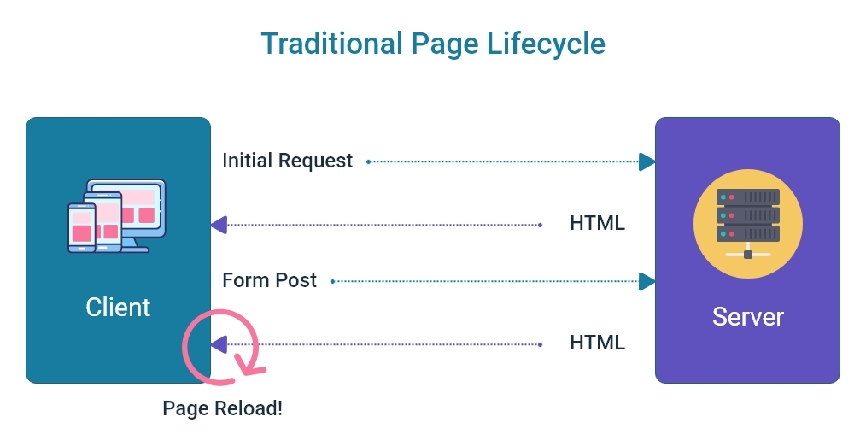



Home

Cart

Blog

Product

User interface

Our shop

Stylist

Single Blog

Single Stylist

Log in

About us

Product

Custom Clothing

Sign up

Contact Us

Single Product

Payment

# Open server

***+Windows/MacOS:***

Step 1: Open folder server with link my-shop/server.

Step 2: Right-click -> open Git bash/Open Terminal on VSCode

Step 3: Enter json-server –watch server.json (Note: you can use “cd server”, sure you are at folder server with file server.json in that)

Step 4: When server was created, open file index.html

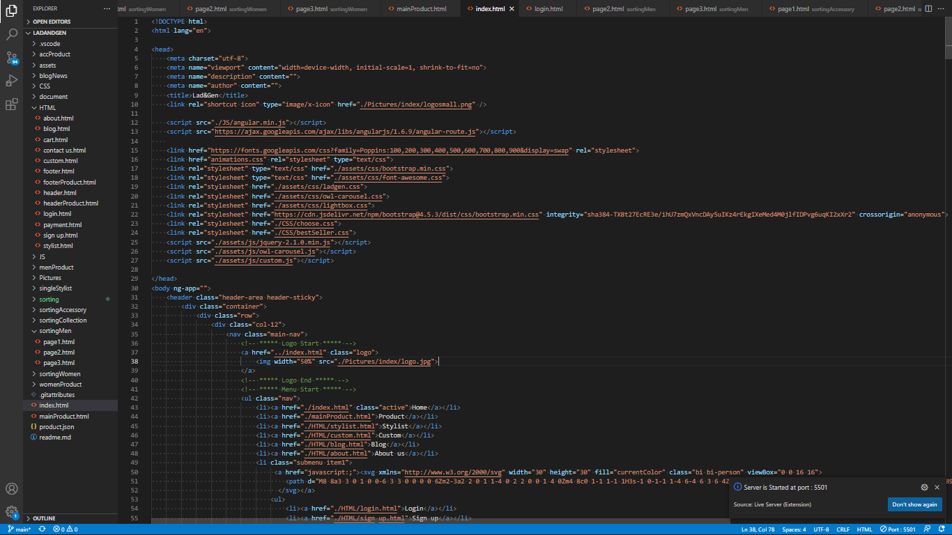

# Screenshots

**I. Homepage:**

1. Navbar with logo, home, categories, about us, contact, user, blog and cart
2. Banner with carousel slide
3. Popular Stylist
4. Categories products of local brands & best seller.
5. Trending & Recommend Items.
6. Introduce collection
7. Accessories & Blog
8. Footer with detail about our store.



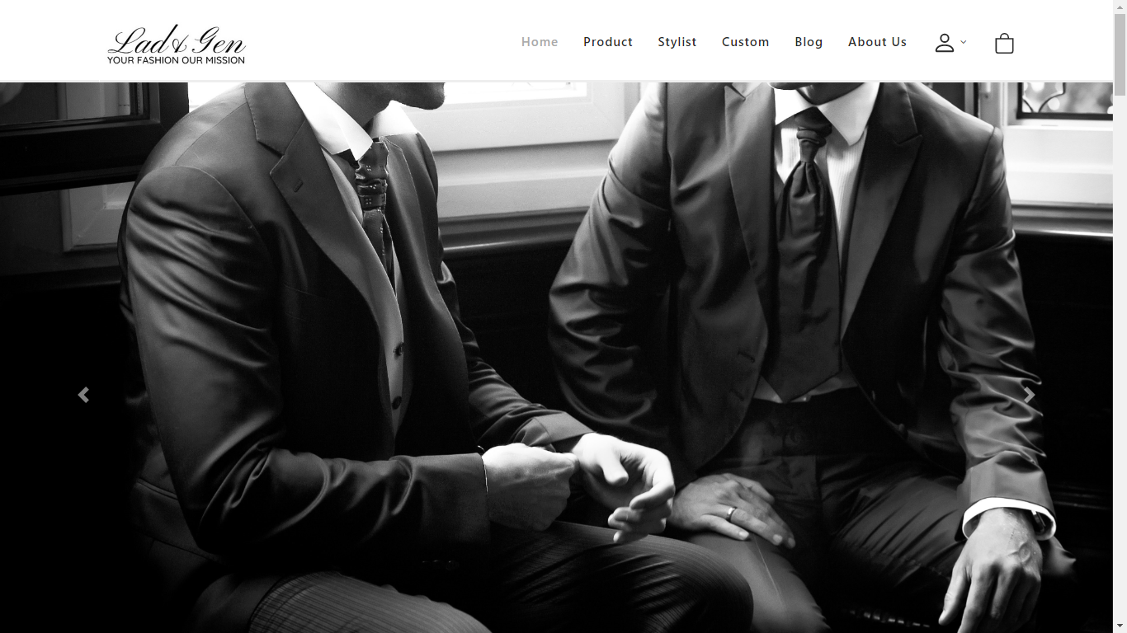This is navbar

*Banner of shop*

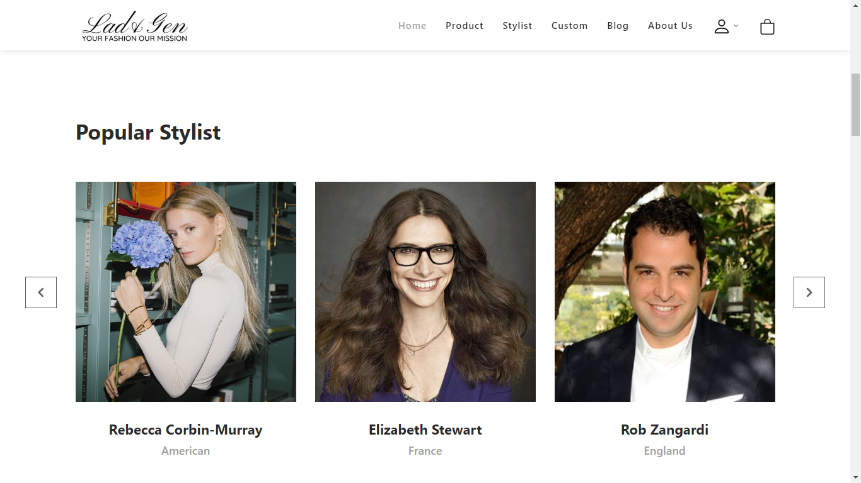

*Popular Stylist*

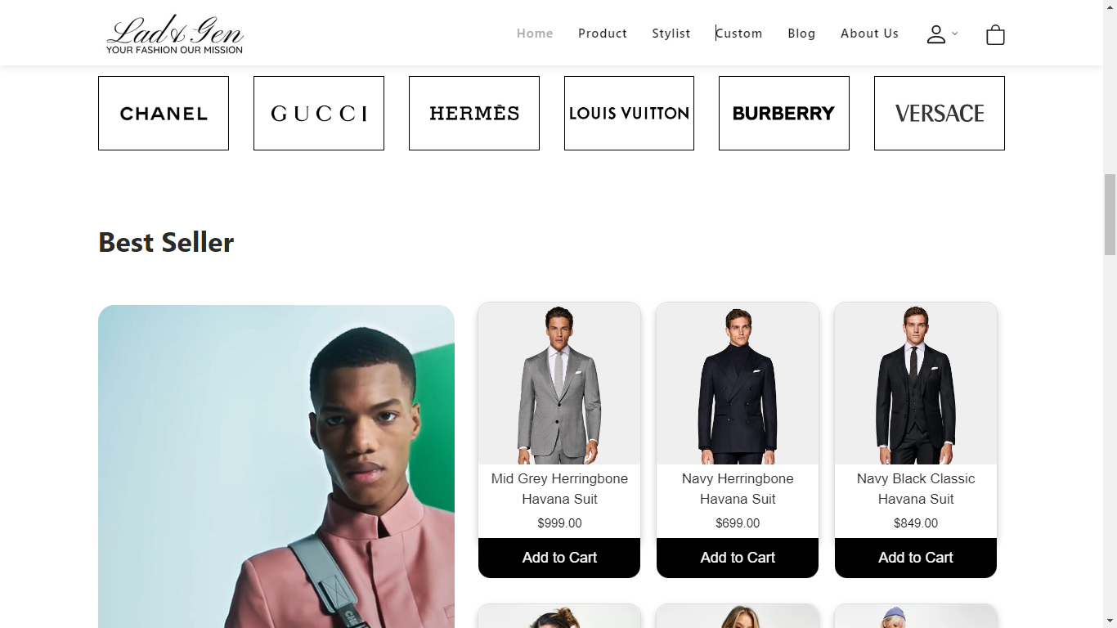

*Categories products of local brands & best seller.*

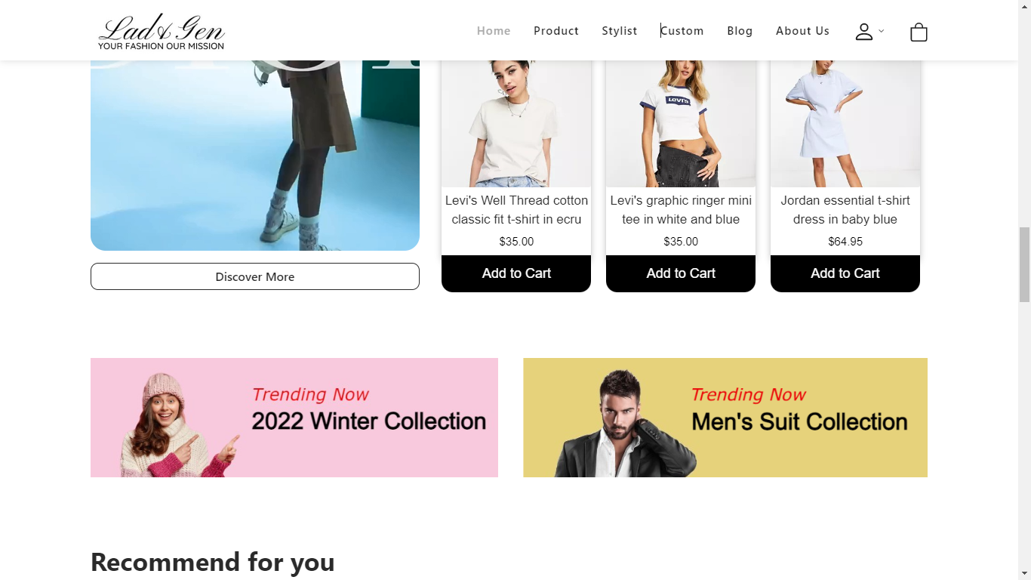

*Trending & Recommend Items.*

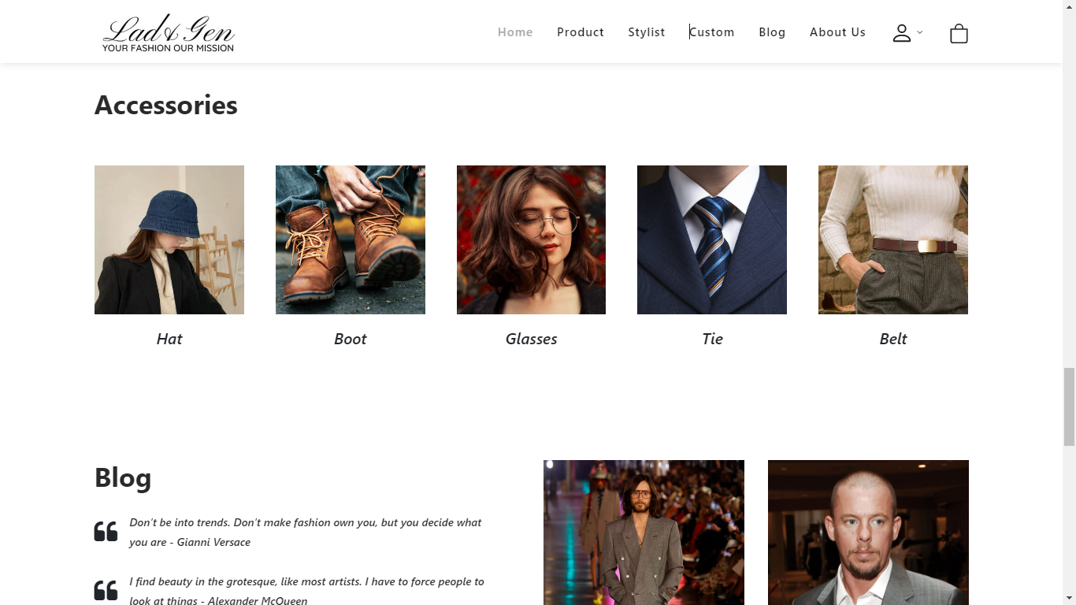

*Accessories & Blog*

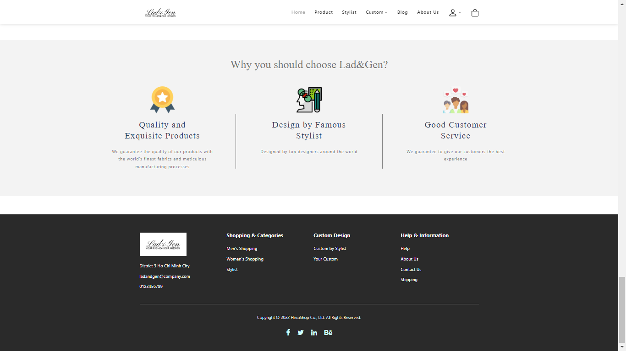

Footer

**Home Page Mobile Responsive**



**Interactive with web at Homepage**

-When you click on Add to Cart, it will save to cart. You can see it in “Cart”.

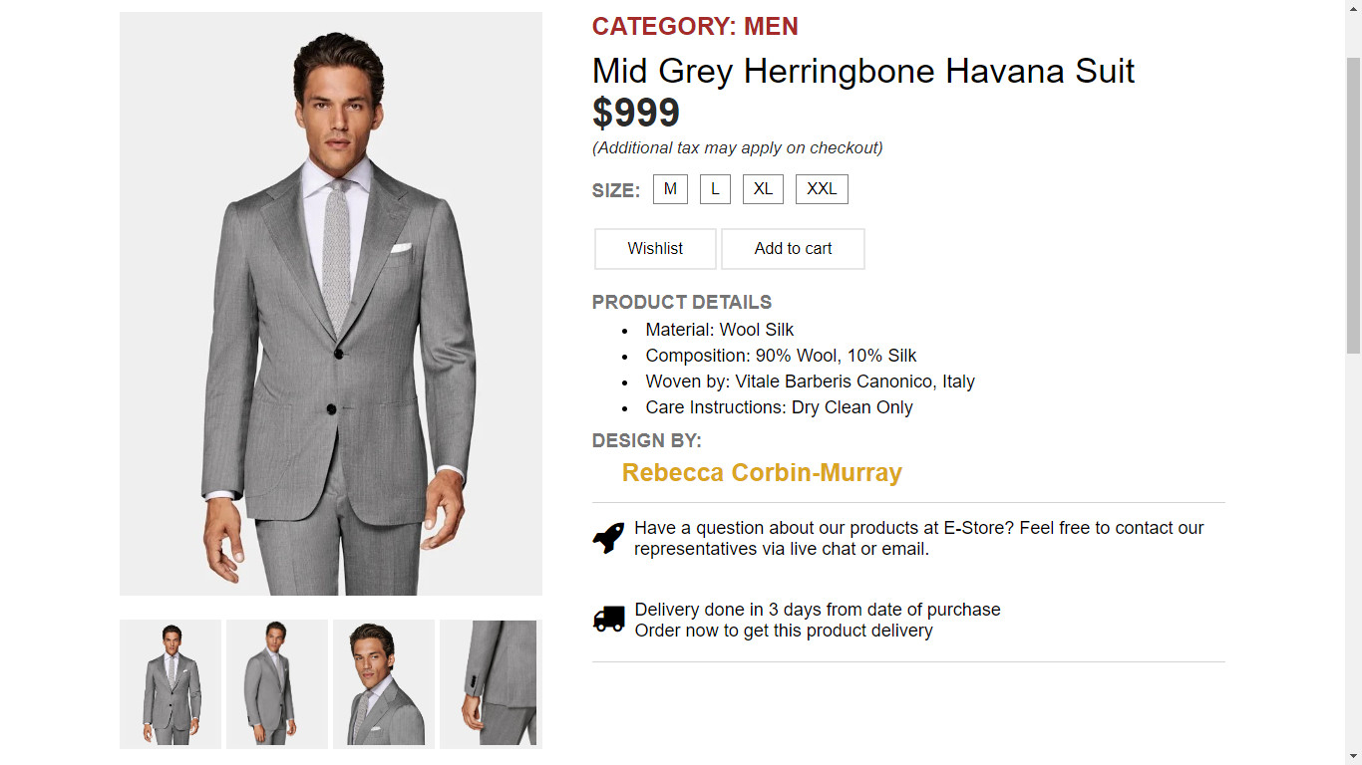

-You can click “cart”, you will see:

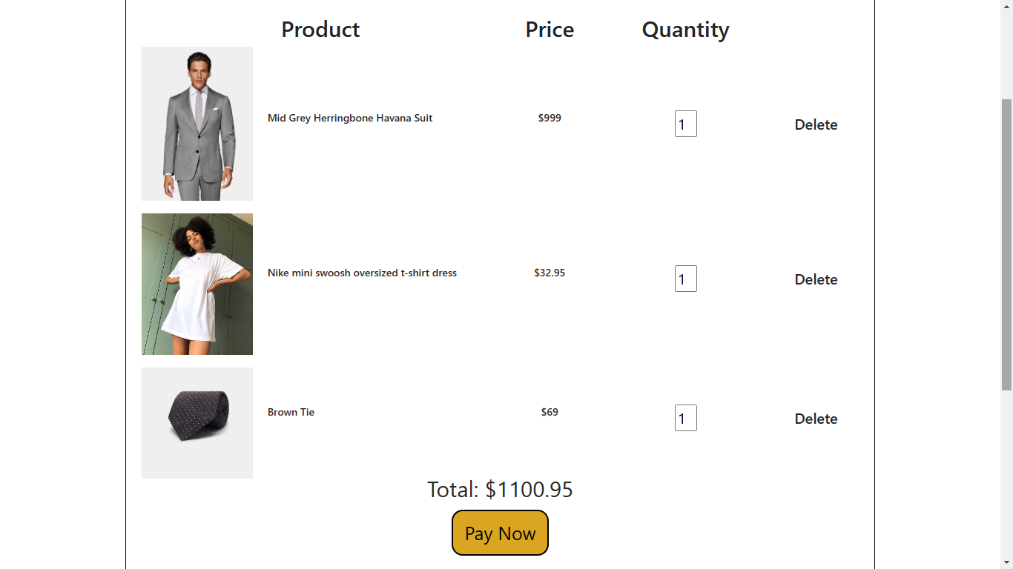

You can see items you chose before.

1.With search, you can find items you chose with product name

2.You can delete item, when you click save icon again.

3.When you click payment, you will go to payment page.

4.You can change value quantity, with min is 1.

**II. Product:**

- All items that store is selling.

- You can easyly find what you need with filter at top corner left. You can find with name items, categories, size or type.

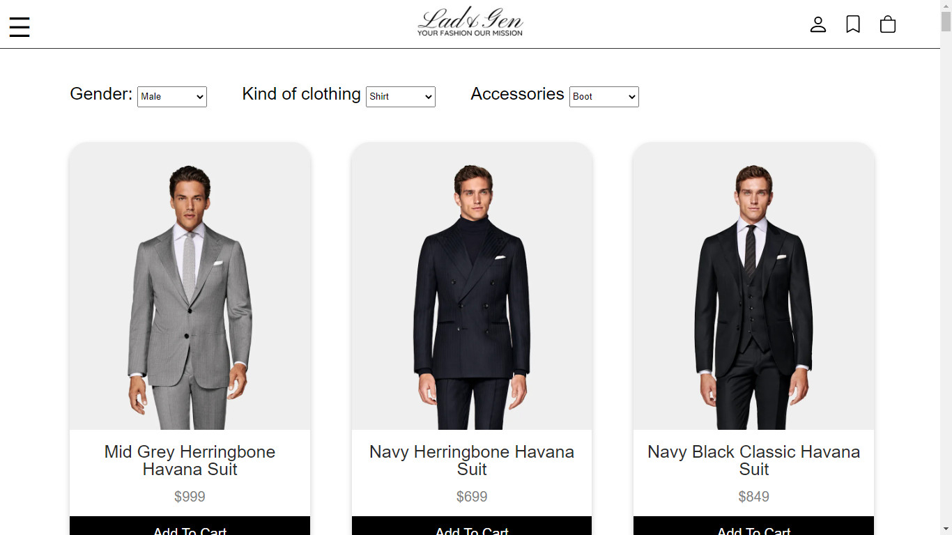

- You can click on each product to see its information and similar product



- You can buy that item, if you click icon . That item will to add to Cart

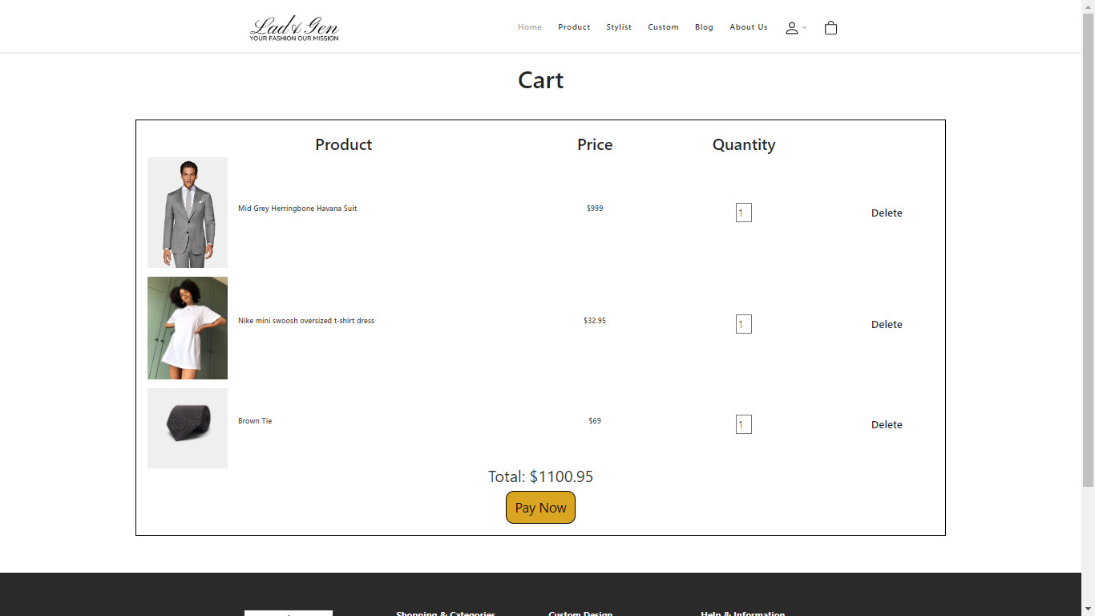

-After checking carefully of items, price and quantity, we will click on check out to fill up information and finish your shopping.

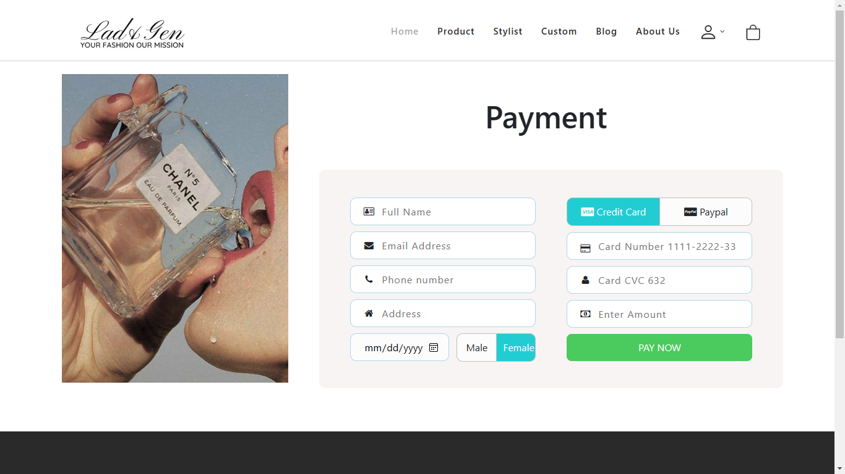

**III. About us:**

- Our story, our vision and a little information about stores:

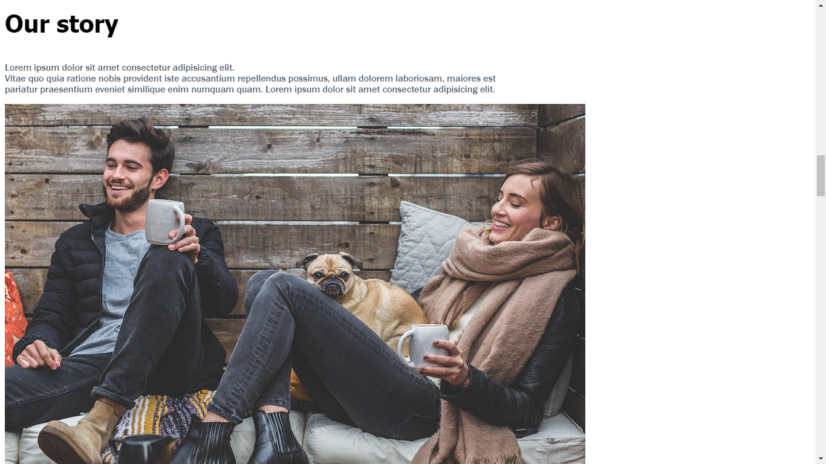

- Our employee:

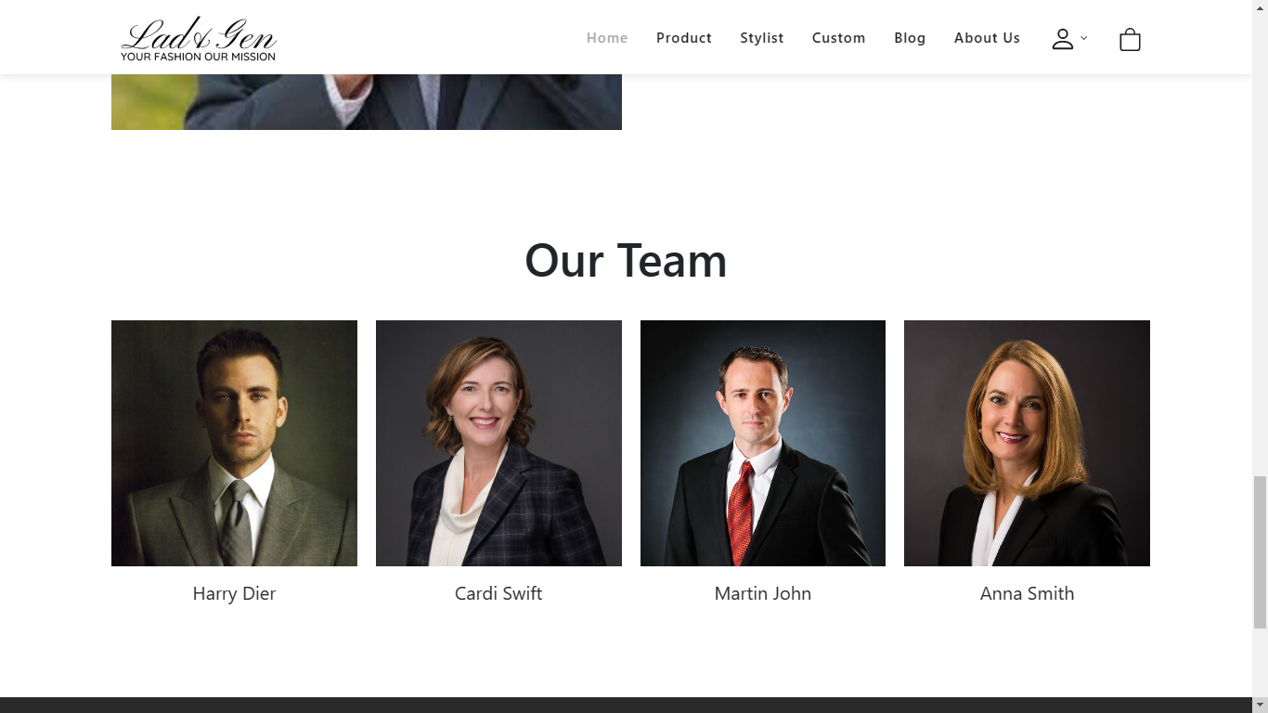

**IV. Contact us:**

# - You can send message to us here and see our shop information

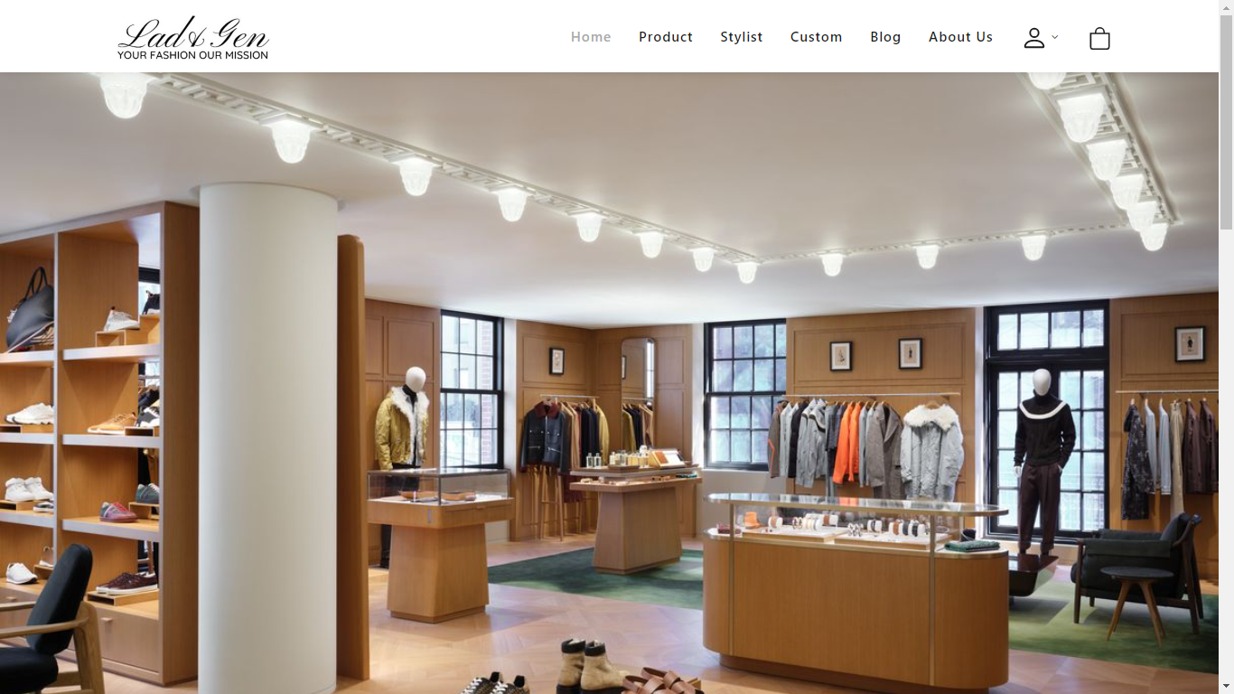

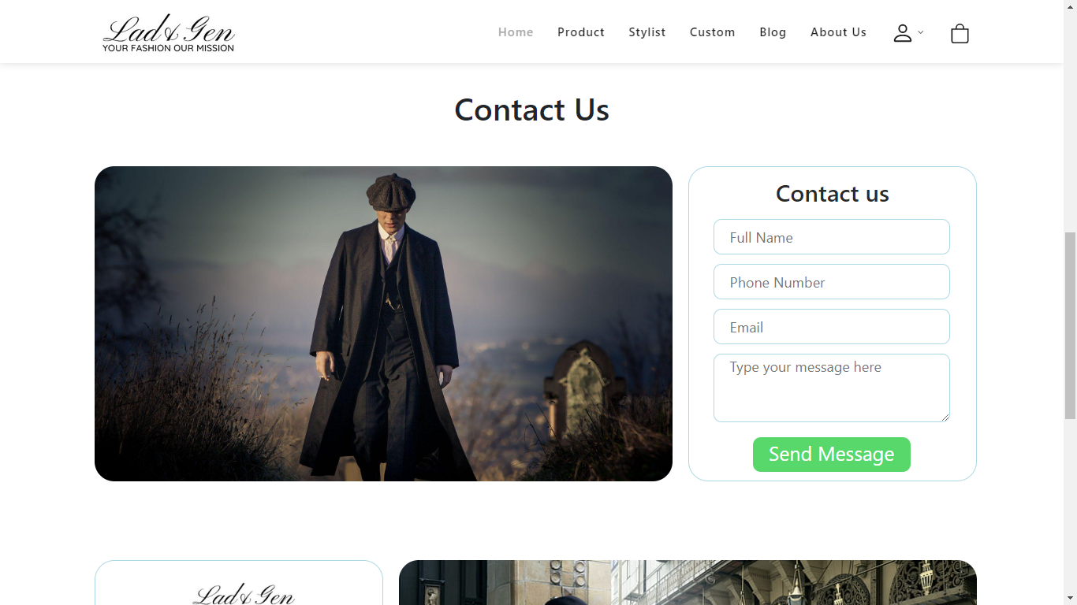

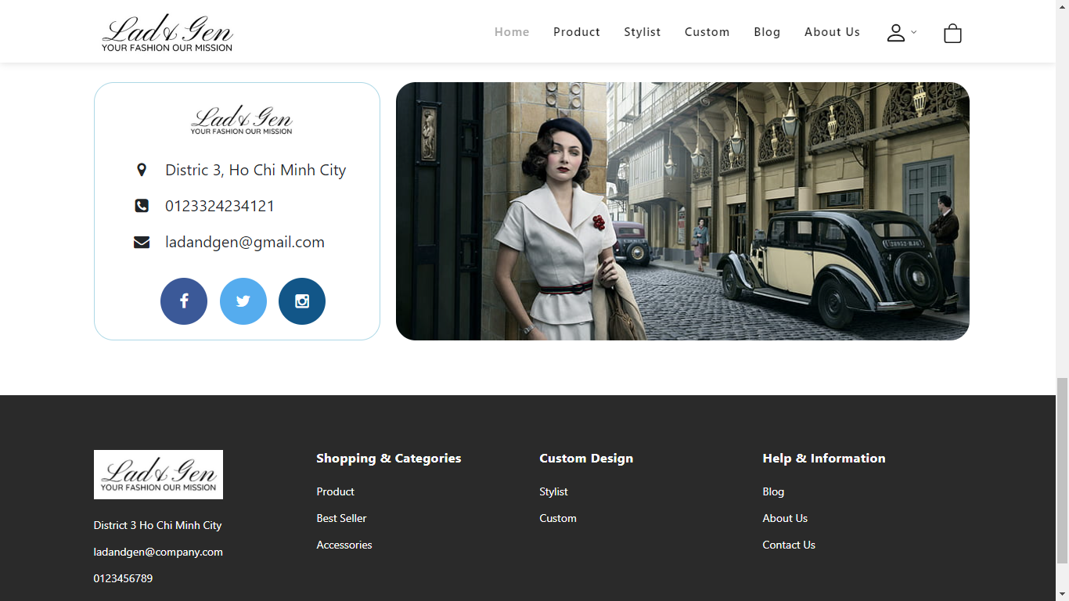

If you send message successfully, the pop-up modal below will appear:

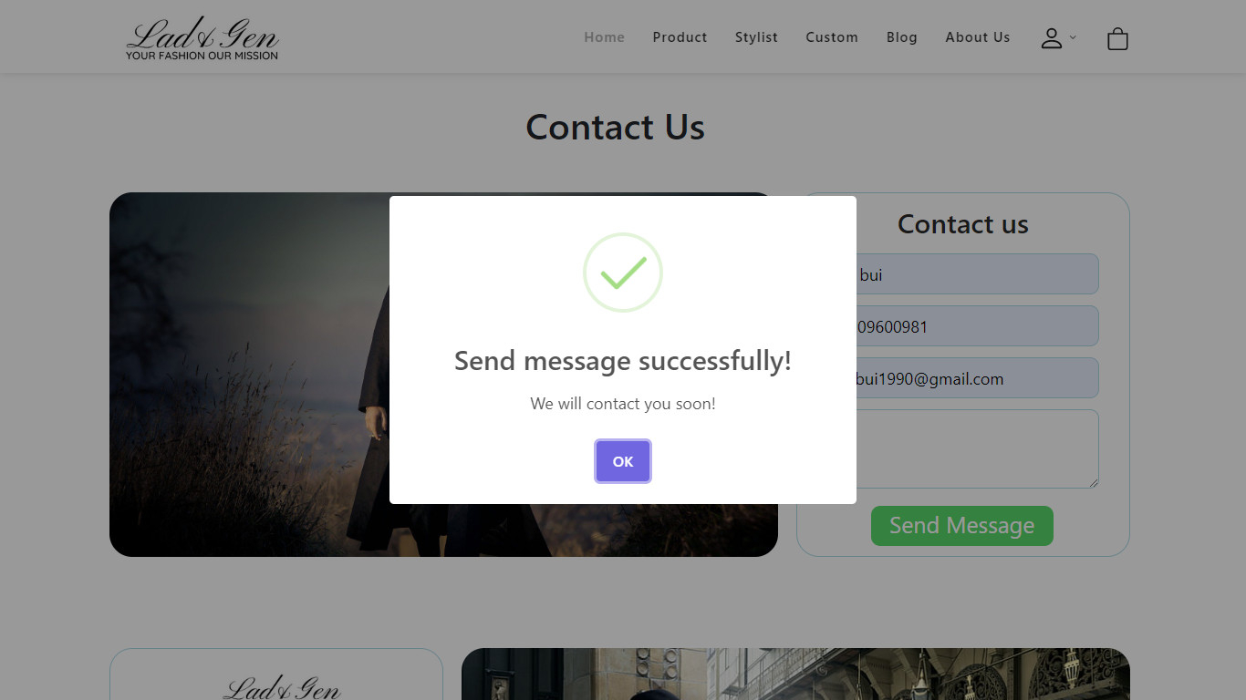

If not, the pop-up modal below will appear:

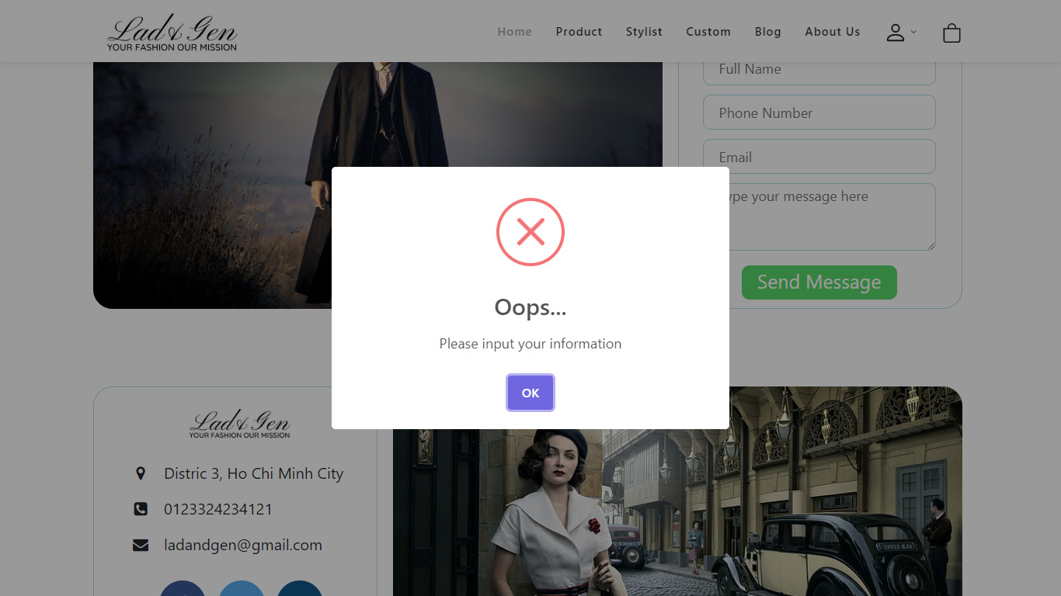

**V. Log in:**

# - In this page you can log in your own account to see your cart, purchase and make the payment.

# 

- When you login successfully, it will appear a pop-up modal:

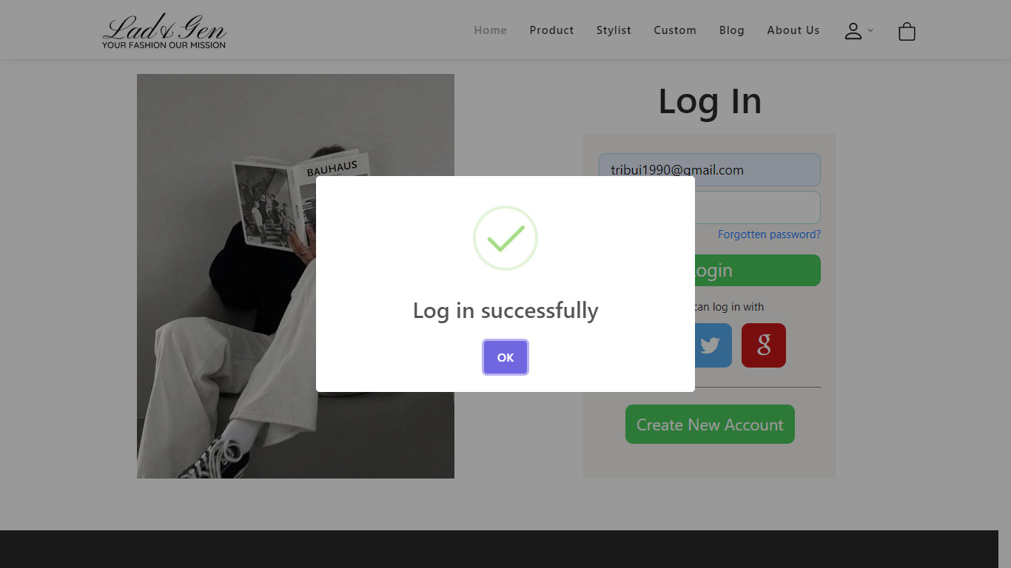

# - If not, it will appear:

# 

**VI. Sign up:**

- If you want to create new account, you can make it in sign up page, you will need to provide account information: username, email, password.

# 

Or you can choose Sign up with social network:

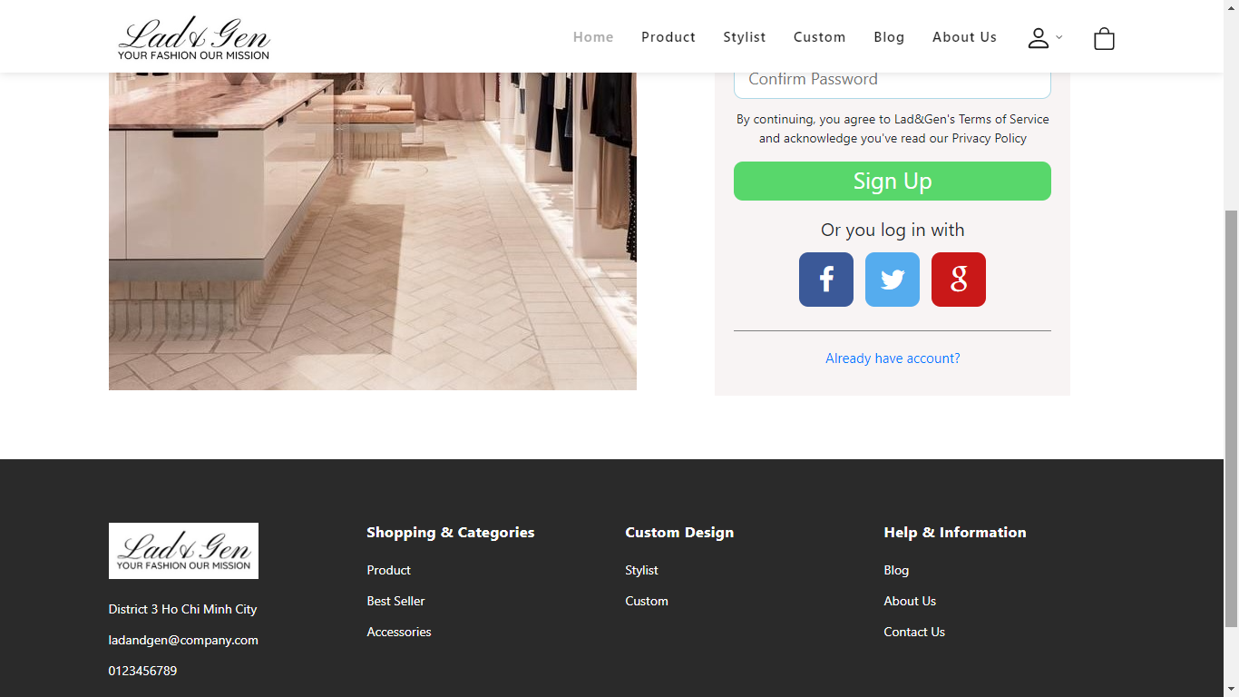

- If you already have an account, it will lead you to Log in page:

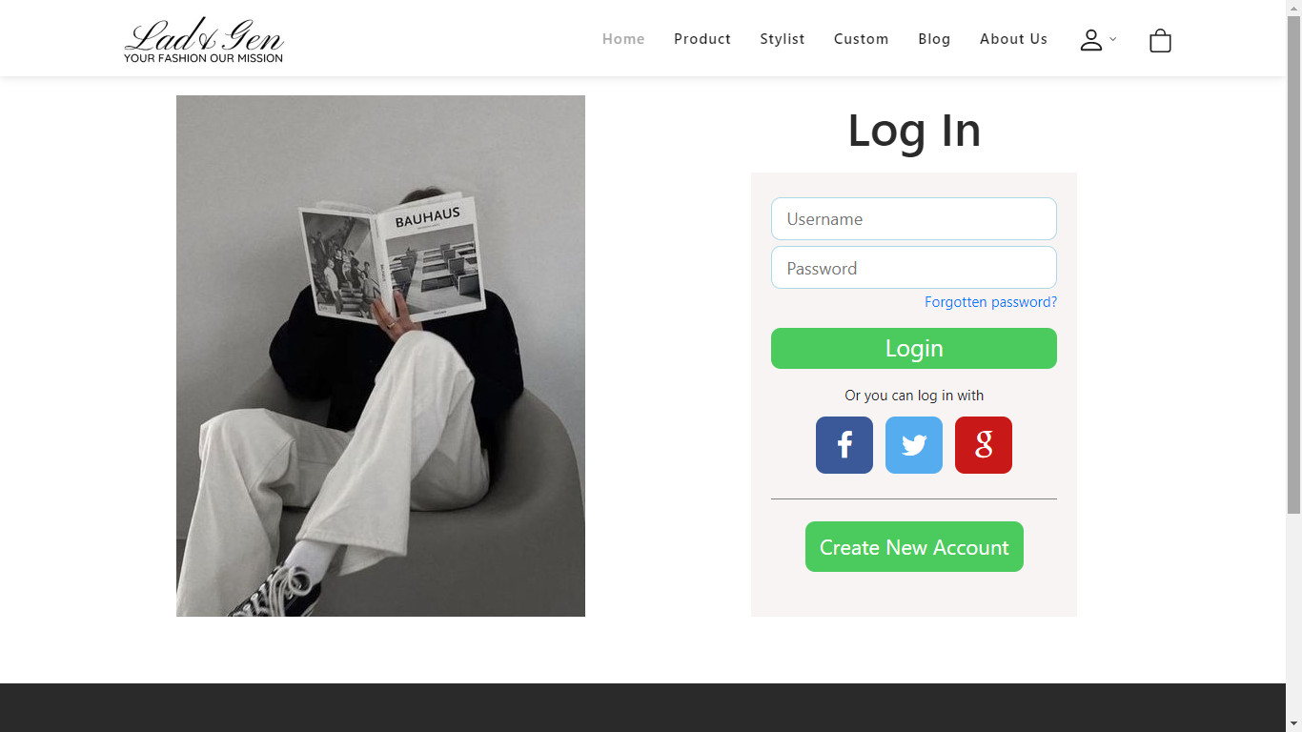

If you sign up successfully, a pop-up modal will appear:

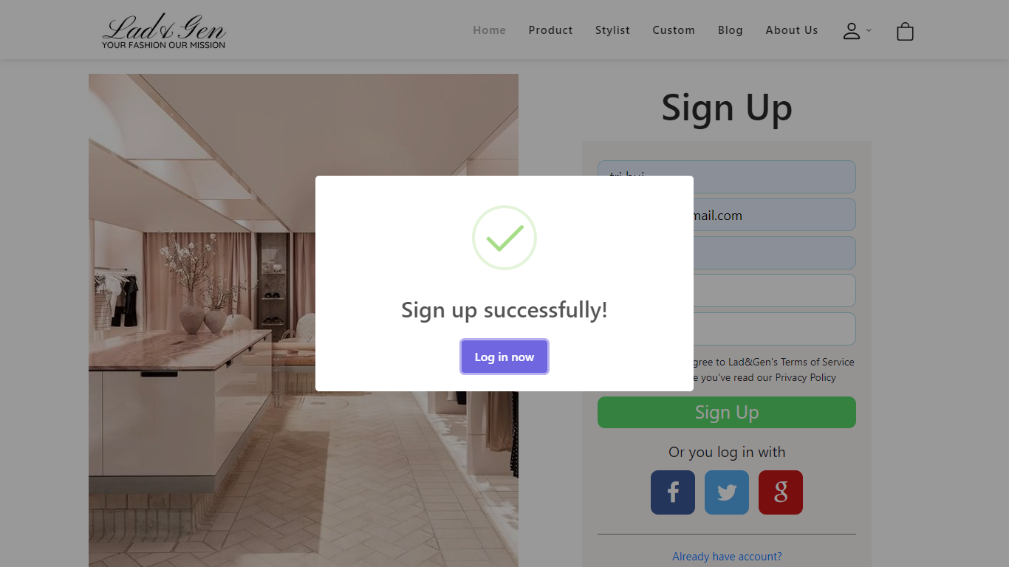

# - If not, it will appear:

# 

# VII. Payment:

- You can purchase your product here

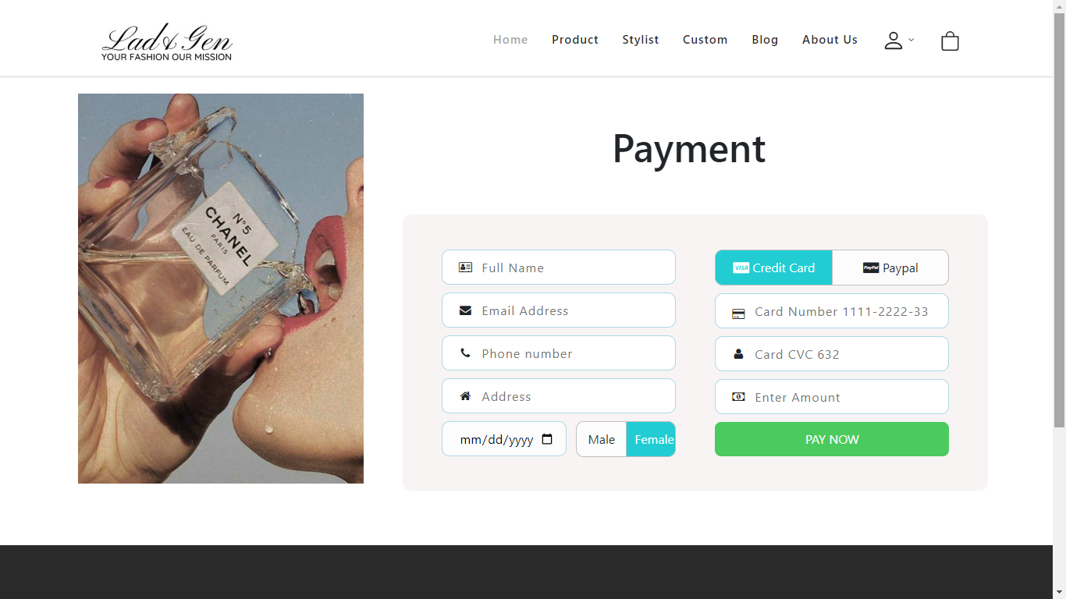

-After fill all information necessary and select your payment, an alert will be showed:

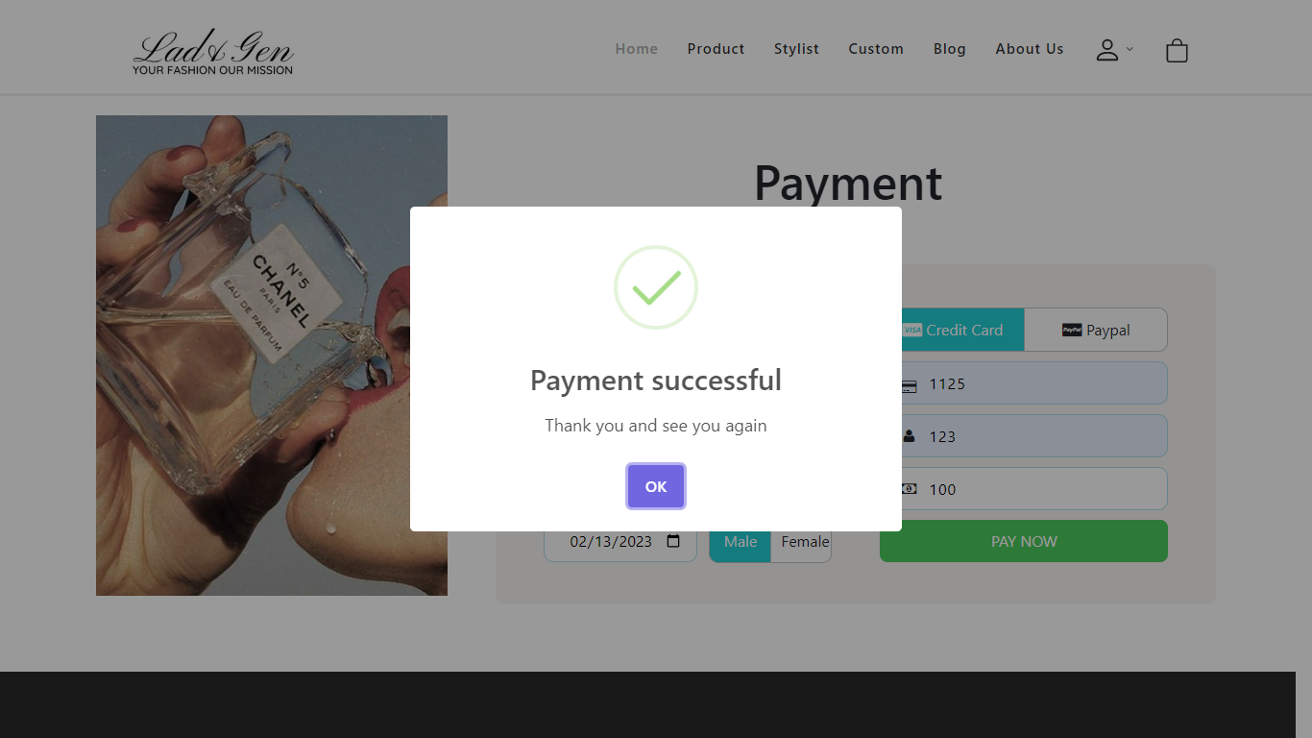

# VIII. Stylist:

# - When you click to stylist page, you can see the list of various famous stylist.

# 

# 

# - When you click on single stylist, it will lead to single stylist page that include stylist’s information and their product

# 

# IX. Blog:

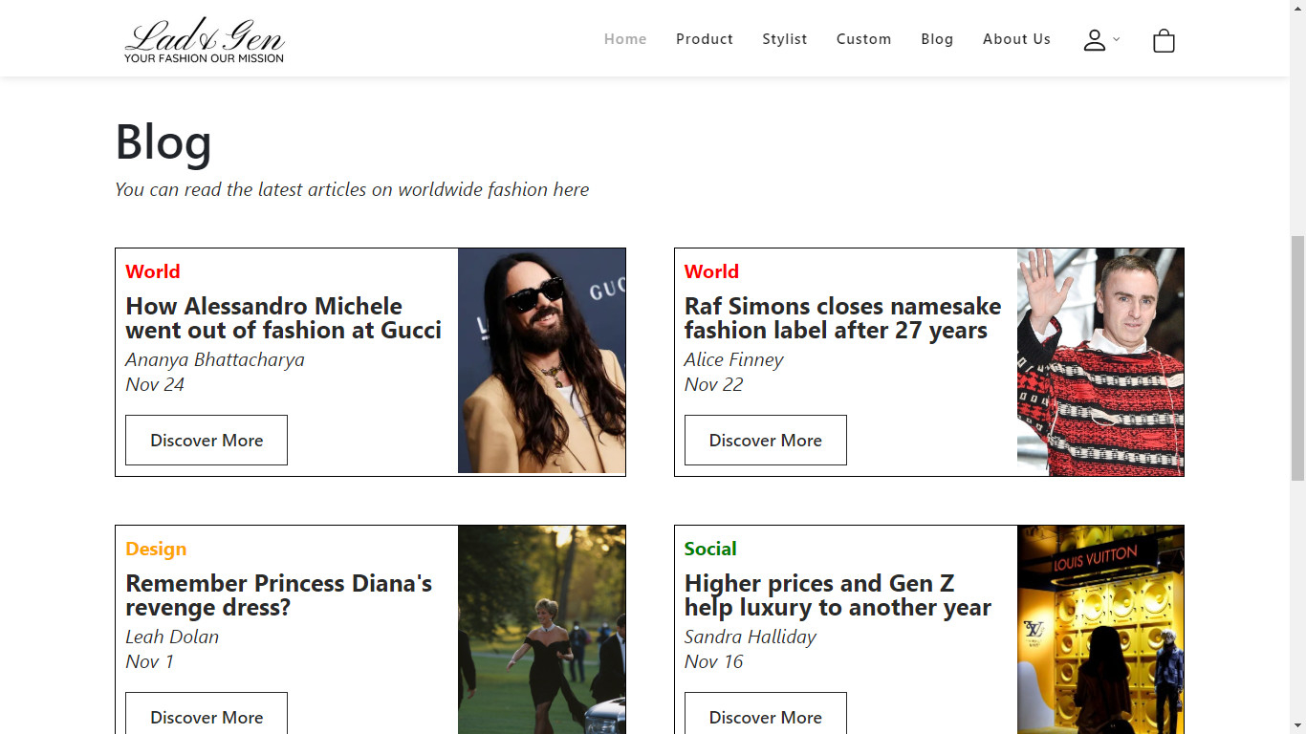 - Our website has blog page that include various news about fashion (stylist, fashion stage, model)

- When you click on the Discover More button, it will lead you to the single blog news that contain news information

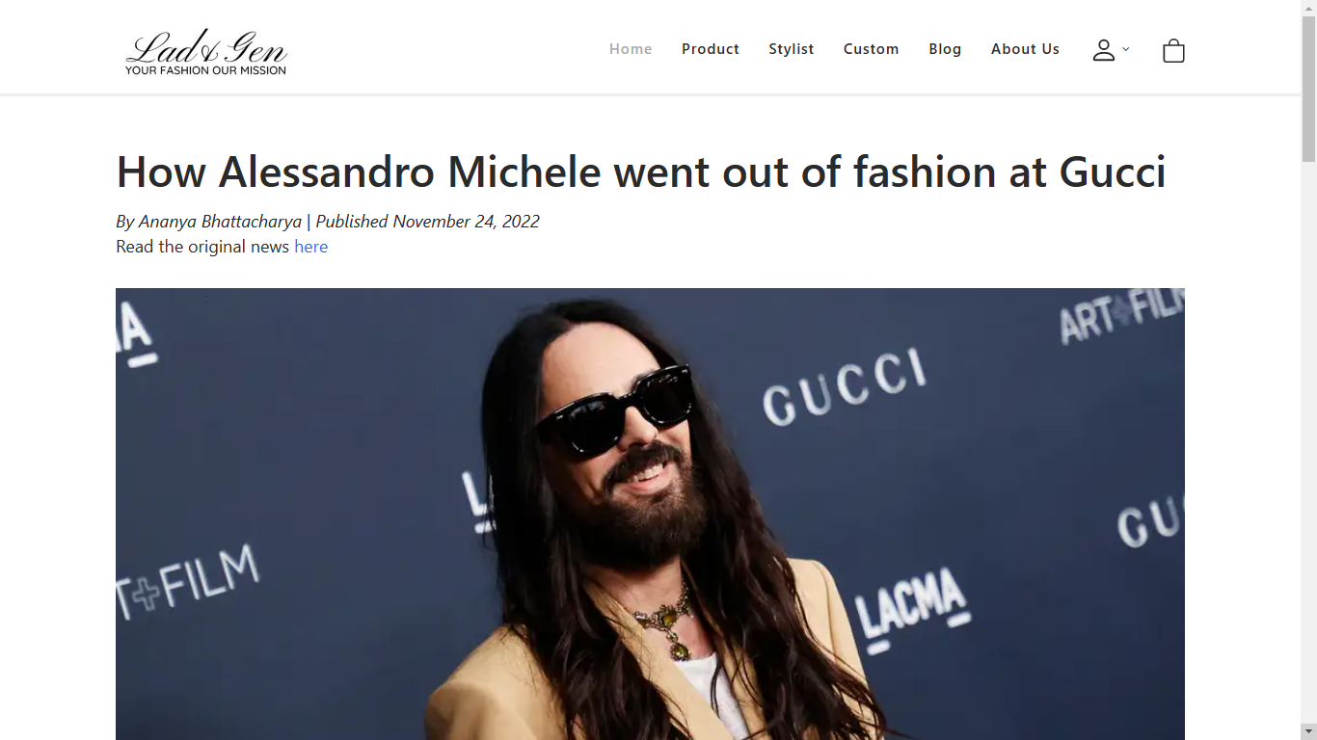



# X. About us:

# - Beside buy clothes in our store, you can also buy the custom clothing which is suittable for you with your own requirements

# - After fill all fields, you will submit it by click on Complete button

# 

# - Then, the pop-up modal will appear to ensure your requierment again

# 

# - After confirm your requirement, our website will lead you to the Payment page

# XI. Cart:

# - When you choose all your wanted product, cart page will show you all of it:

# 

# - When you ensure all these products, you can pay it by click on the Pay Now button:



Task sheet

|  |  |  |  |  |  |  |  |
| --- | --- | --- | --- | --- | --- | --- | --- |
| No | Member | Contents | Page Name | Activity Plan | Date of Preparation of Activity Plan | | |
| Planed Start Date | Actual Start Date | Actual End Date | Status |
| 1 | Bùi Trần Anh Trí | Payment | payment.html | 16/11/2022 | 16/11/2022 | 16/12/2022 | 100% |
| Products | Products.html | 16/11/2022 | 16/11/2022 | 16/12/2022 | 100% |
| Cart | cart.html | 16/11/2022 | 16/11/2022 | 16/12/2022 | 100% |
| 2 | Phạm Tiến Đức | Home | index.html | 16/11/2022 | 16/11/2022 | 16/12/2022 | 100% |
| Blog | blog.html | 16/11/2022 | 16/11/2022 | 16/12/2022 | 100% |
| Logo/JavaScript |  | 16/11/2022 | 16/11/2022 | 16/12/2022 | 100% |
| Stylist | Stylist.html | 16/11/2022 | 16/11/2022 | 16/12/2022 | 100% |
| 3 | Hoàng Ngọc Phú | Login | login.html | 16/11/2022 | 16/11/2022 | 16/12/2022 | 100% |
| Sign up | Sign up.html | 16/11/2022 | 16/11/2022 | 16/12/2022 | 100% |
| About Us | aboutus.html | 16/11/2022 | 16/11/2022 | 16/12/2022 | 100% |
| Contact Us | contactus.html | 16/11/2022 | 16/11/2022 | 16/12/2022 | 100% |
| 4 | Nguyễn Hoàng Trung | Picture design |  | 16/11/2022 | 16/11/2022 | 16/12/2022 | 100% |
| Logo design |  | 16/11/2022 | 16/11/2022 | 16/12/2022 | 100% |
| Cart | cart.html | 16/11/2022 | 16/11/2022 | 16/12/2022 | 100% |